# **OPTIMISING TIME-LIMITED NON-PHARMACEUTICAL INTERVENTIONS FOR COVID-19 OUTBREAK CONTROL**

Alex L.K Morgan1, Mark E.J Woolhouse12, Graham F. Medley3 and Bram A.D van Bunnik12

1Centre for Immunity, Infection & Evolution and School of Biological Sciences, University of Edinburgh, Edinburgh, United Kingdom

2Usher Institute, University of Edinburgh, Edinburgh, United Kingdom

3Centre for Mathematical Modelling of Infectious Diseases, London School of Hygiene and Tropical Medicine, London, United Kingdom

## **ABSTRACT**

The introduction of non-pharmaceutical interventions (NPIs) to combat the ongoing COVID-19 outbreak has proven to be controversial, with economic, mental and general physical health-related repercussions resulting from these measures. This has led to concept of intervention optimisation, allowing for policy makers to manage the duration, introduction and strength of NPIs, to minimise the human health effects resulting from both COVID-19 and the intervention itself. Here, we use epidemiological modelling to investigate the feasibility of optimising five different NPI scenarios, to minimise the human health repercussions in a simulated UK COVID-19 outbreak.

An optimal parameter space was identified to optimise all five NPI scenarios. However, these optimums were extremely narrow and therefore difficult to obtain in practice by policy makers. Greater focus should be placed on sub-optimal interventions which can still effectively mitigate human health impacts from COVID-19 over a wider parameter space and therefore give policy makers greater room for error when introducing effective intervention measures. These suboptimal intervention strategies were identified for all considered NPI scenarios. This work provides a simple illustrative example of the concept of intervention optimisation across a wide range of different scenarios and serves as a basis for future in-depth modelling work.

## **INTRODUCTION**

The ongoing COVID-19 pandemic has highlighted the vital role of non-pharmaceutical interventions (NPIs) on mitigating the spread of SARS-COV-2. These interventions break chains in transmission through population and individual-level behavioural changes, which can consequently reduce opportunities for transmission **(1)**. NPIs also encompass a large range of potential outbreak control strategies, ranging from simple advice to encourage hand-washing to country-wide stay-at-home orders, colloquially known as lockdown measures **(2)**.

While an effective tool to drive down disease prevalence, lockdown measures are considered unsustainable and time-limited, with harsh economical, physical and mental health repercussions during and following the cessation of these interventions **(3-5)**. This has driven calls to retrospectively understand the human health impact of introducing these lockdown measures under a different set of circumstances. This includes insight into how differences in the timing, duration and strength of lockdown measures could have potentially reduced COVID-19 associated mortality and morbidity compared to the actual course of action (**6-9**).

Exploratory epidemiological modelling into “optimising” NPIs and lockdown measures has arisen from these research questions **(10-16)**. The concept of intervention optimisation is based on the potential for policy makers to fine-tune the characteristics of an intervention, such as the day at which the intervention is triggered, the intervention duration and the magnitude of the intervention, to minimise epidemiologically relevant outcome measures. One such desired outcome includes minimising the peak prevalence/incidence, analogous to “flattening the curve” of an outbreak. This was a hard lesson learned during early COVID-19 outbreaks in Lombardy, Veneto and Wuhan, with the straining of ICU bed capacity and subsequent overwhelming of health services resulting in severe impacts on patient mortality **(17, 18)**. These interventions also seek to minimise the final outbreak size and delay the timing of the epidemic peak, with this allowing for a greater amount of time to build-up health system resilience, such as contact-tracing capacity, and enable vaccine development.

Optimisation has been explored for a large range of potential COVID-19 NPI strategies, including single time-limited reductions to transmission (**10, 11**), intermittent pulsing of lockdown measures **(15)** and gradual ramping-down of NPIs following an initial lockdown (**12, 13**). Despite an optimal parameter space being identified for each of these explored interventions, research has questioned the ability for policy makers to achieve these results in practice (**10**). This stems from the narrow windows for optimal timing and the adverse human health outcomes borne out of implementation error (**10, 12**). An alternative strategy is to use generalised intervention strategies, such as using a longer-than-optimal or earlier-than-optimal intervention strategies, with the aim to identify broad, achievable, sub-optimal parameter spaces that can still somewhat minimise detrimental human health effects. While not as obviously beneficial as optimal interventions, these sub-optimal interventions are more robust to implementation error and offer more practical guidance to policy makers than specific optimal intervention timings or durations (**10**).

This study aims to provide a unifying mathematical modelling framework to explore the concept of optimal and suboptimal interventions across a range of different NPI scenarios. We explore the existence, patterns and optimal parameter spaces for each intervention to minimise either the maximum peak prevalence or total cumulative incidence. This was explored for three main parameters considered alterable by policy makers: 1) intervention duration, 2) intervention strength and 3) the date of the intervention trigger. We subsequently investigated the interplay between these parameters on model dynamics through a series of sensitivity analyses. The results from this study are not intended as a framework to decide the best course of action. Rather this analysis provides an illustrative example to describe how optimal and sub-optimal outbreak control can be achieved under different circumstances and intervention strategies.

## **METHODS**

* 1. **SIR Model Structure**

A deterministic SIR model was used to explore the impact of time-limited non-pharmaceutical interventions (NPI) on a simulated UK-based COVID-19 outbreak (**19**). *S*, *I* and *R* compartments were used to denote the fraction of susceptible, infected and recovered individuals respectively within the population, with *S + I + R = 1* (**eqn 1.1**). The effects of demography were ignored for this model (births, deaths, migration, etc.).

$$\frac{dS}{dt}=-β(t)SI$$

$$\frac{dI}{dt}=β(t)SI-γI$$

$$\frac{dR}{dt}=γI$$

eqn 1.1

Susceptible individuals (*S*) are infected at the time-varying rate *β(t)*, which represents the daily per-capita rate of transmission in a randomly-mixing population. Infected individuals (*I*) recover at rate *γ*, representing the daily per-capita rate of recovery. This rate was taken as the inverse of the average duration of infectiousness. A baseline pre-NPI basic reproduction number (*R0*) of 2.8 and doubling time (*Td*) of 3 days were assumed, in line with estimates for COVID-19 transmission in the UK and abroad (**20-24**). The generation time was calculated as a function of these two quantities (**25**), with a baseline generation time of 7.79 days and a resulting *γ* of 0.128 (**eqn 1.2**).

eqn 1.2

* 1. **Defining the time-varying β(t)**

By setting *β = R0γ*, we define the baseline per-capita transmission rate in the absence of NPIs, *β = 0.359*. To capture the impact of small-scale NPIs (excluding population lockdown), *β* was multiplied by a scaling factor of 0.7, *βscale = 0.252*, with this 30% reduction being roughly in line with estimates of the impact of NPIs, such as school-closures, introduction of social distancing and isolation upon COVID-19 symptoms, and excluding lockdown measures (**24, 26, 27**). Using the UK as a representative example, these measures were introduced between 12-21st March 2020 with lockdown measures initiated on the 25th March 2020 (**27**). We assume that these measures are in place at the initiation of the model simulation.

*β(t)* is defined as the product of *βscale* and a time-varying scaling factor *c(t)*, which reduces *βscale* over the course of the simulation to model the impact of lockdown measures, with *0 ≤ c(t) ≤ 1*. Reductions associated with this scaling factor are introduced on the lockdown trigger day, *tp*. This is defined as:

$$β(t)=\left\{\begin{aligned}β_{scale}, &t<t_{p} \\ {c(t)β}_{scale}, &t_{p}≤t≤t_{p}+d_{t} \\ β_{scale}, &t>t_{p}+d_{t}\end{aligned}\right.$$

The shape of *c(t)* varies with the different lockdown scenarios explored, with parameter *cmin* describing the minimum value of *c(t)* during the intervention. This can be considered a proxy measure of the magnitude of the intervention. This parameter ensures that for each considered intervention scenario, the same minimum value of *c(t)* and therefore *β(t)* is reached.

For baseline reductions to *β(t)* we define *cmin* = 0.4, resulting in *β*(t)= 0.101when the lockdown measures are at their greatest magnitude*.* Baseline *cmin* was chosen to roughly achieve an effective reproduction number (*Re*) of *0.7 ≤ Re ≤ 1* during lockdown, similar to that observed in COVID-19 literature (**24, 26, 27)**, with *Re* defined as *R0S*. All lockdown interventions were initiated at baseline *tp* = 52 days, equivalent to a total cumulative infected fraction at the initiation of population lockdown, *Ic*(52)= 0.02, in line with model-based UK COVID-19 estimates (**27**). The model was seeded with an initial infectious fraction, *I*(0) = 0.00001.

We note that *tp* = 52 days represents a significantly higher value compared to the UK intervention timeline (~13 days). However, with a sufficiently large initial infected fraction and with the model *tp* occurring at an epidemiologically accurate cumulative incidence, we note that the initial epidemic dynamics can be accurately captured, while simultaneously increasing model tractability, as it then becomes unnecessary to model the exact UK COVID-19 intervention timeline.

* 1. **Single Intervention Population Lockdown**

A time-limited population lockdown was the primary NPI explored in this model, with optimisation occurring in relation to this intervention. We explored five different lockdown strategies, with each intervention differing with regards to the shape of *c(t)* and the subsequent *β(t)* reductions over the duration of the intervention duration, defined as *dt* (**Table 1**). The model simulation was run for 400 days. We provide the rationale and real-world parallels for each of these scenarios in the ***supplementary material***.

**Table 1** – Description of the five lockdown interventions.

|  |  |  |
| --- | --- | --- |
| Scenario | *c(t)* during the simulation | Definition of *c(t)* scaling parameter |
| 1 | Immediate and constant reduction to *cmin*. |  |
| 2 | Immediate reduction to *cmin* followed by a linear increase back to *c(t)* = 1. | $$c(t)=c_{min}+\frac{1-c_{min}}{d_{t}}(t-t_{p})$$ |
| 3 | Linear decrease to *cmin* followed by an immediate return to *c(t)* = 1. | $$c(t)=1-\frac{1-c_{min}}{d_{t}}(t-t_{p})$$ |
| 4 | Linear decrease to *cmin* at *dt*/2, followed by a linear increase back to *c(t)* = 1. | $$c(t)=\left\{\begin{aligned}1-\frac{1-c_{min}}{\frac{d_{t}}{2}}(t-t_{p}), &t_{p}≤t<t_{p}+\frac{d_{t}}{2} \\ c_{min}+\frac{1-c_{min}}{\frac{d_{t}}{2}}(t-t_{p}), &t_{p}+\frac{d_{t}}{2}≤t≤t_{p}+d_{t}\end{aligned}\right.$$ |
| 5 | A “pulsing” lockdown with immediate reductions to *cmin* between intervention intervals 0-21, 35-49 and 63-77 days (for an example total intervention duration, *dt* = 84 days). | $$c(t)=\left\{\begin{aligned}c_{min}, &t_{p}≤t<t_{p}+{0.167d}_{t} \\ 1, &t_{p}+0.167d_{t}≤t<t_{p}+{0.333d}_{t} \\ c_{min}, &t_{p}+0.333d_{t}≤t<t_{p}+{0.5d}_{t} \\ 1, &t_{p}+0.5d_{t}≤t<t_{p}+{0.667d}_{t} \\ c_{min}, &t_{p}+0.667d_{t}≤t<t_{p}+{0.833d}_{t} \\ 1, &t≥t_{p}+{0.833d}_{t}\end{aligned}\right.$$ |

For a total length of intervention duration, *dt*, the magnitude of *c(t)* scaling reductions over the intervention period is half for scenario 2, 3, 4 and 5 relative to scenario 1. To maintain comparable overall *β(t)* reductions over the intervention period, *dt* was doubled for scenario 2, 3, 4 and 5 relative to scenario 1 for baseline analyses. This corresponds to *dt* = 84 days for scenario 1 (12 weeks) and *dt* = 168 days (24 weeks) for all other scenarios.

An alternative approach was considered by keeping *dt* constant and doubling *cmin* reductions observed in scenario 2, 3, 4 and 5 relative to scenario 1 (**Figure S1 + 2**). Either method is plausible when considering potential intervention scenarios, but we argue that in practice it is more plausible to alter *dt* than it is to alter *cmin* in a public health context.

* 1. **Multiple Intervention Population Lockdowns**

To explore the transmission dynamics resulting from multiple time-limited lockdown measures, two interventions were modelled sequentially over the course of the simulation. The generic shape of *c(t)* reductions for the five different lockdown scenarios were kept constant for both intervention 1 and 2 (**Table S2**). We define the minimum value of the lockdown-related *c(t)* scaling factor, lockdown trigger point and duration of the intervention as *cmin1* and *cmin2*, *tp1* and *tp2*, and *dt1* and *dt2* respectively for intervention 1 and 2. We highlight that *tp2* is defined relative to the end of intervention 1, with the exact start of intervention 2 defined as *t* = *tp1* + *dt1* + *tp2*.

Baseline *dt1*  and *dt2* for multiple interventions were halved relative to the single intervention scenarios to ensure that the interventions could occur within the timeframe of the simulated epidemic curve. Similar to the single intervention scenario, the intervention duration of scenario 2, 3, 4 and 5 were doubled relative to scenario 1 to ensure comparable magnitudes of *β(t)* reductions over the intervention period. Baseline parameter values for the multiple intervention scenario were set at *dt1* = *dt2* = 42 days (6 weeks) for scenario 1 and *dt1* = *dt2* = 84 days (12 weeks) for scenarios 2, 3, 4 and 5. The minimum value of lockdown-related scaling factor *c(t)* was kept static at baseline for both interventions at *cmin1* = *cmin2* = 0.4. The model simulation was run for 730 days.

* 1. **Outcome Measures of Interest**

The primary objective of all analyses in this study was to identify the optimal parameter space for the intervention trigger point (*tp*), duration (*dt*) and magnitude (cmin) to minimise the values of two outcome measures:

1. Maximum peak prevalence *I(t): Imax*
2. Total cumulative incidence: $I_{c}\left(∞\right) =\lim_{t→∞}{I_{c}(t)}$ equivalent to *R(∞) = 1- S(∞)*

We define *Imax* as the global maximum of the function describing the trajectory of the epidemic, with subsequent references to “epidemic peaks” describing the local maximums where *I(t) > 0* and *I’(t) = 0*. The optimal parameter is defined as the combination of parameter values that result in the lowest possible value of *Imax* or *Ic(∞)* in the explored parameter space.

1. **Software Used**

All model simulations were carried out using R (v3.6.2) and Rstudio. The following packages were used for all R-based simulations and plotting: “*desolve*” (v1.28), “*ggplot*2” (v3.3.2), “*reshape2*” (v1.4.4) and “*ggpubr*” (v0.4.0).

**RESULTS**

Using baseline intervention parameters, the impact of the five intervention scenarios on the trajectory of the simulated COVID-19 simulation was qualitatively explored (**Figure 1A**). Scenario 1 and 2 resulted in the suppression of the initial outbreak following the initiation of lockdown measures (*Re* > 1), with a notable delay in the timing of the maximum peak prevalence. This can be attributed to the large pool of remaining susceptibles following the cessation of the intervention, due to strong initial lockdown measures. In contrast, a single mitigated epidemic peak was observed for scenario 3 and 4. The steady ramping up of *β(t)* reductions and the protective effects of population immunity resulted in a more gradual, albeit sustained reduction to *Re* below 1, preventing the resurgence or delaying effect of a second epidemic peak. The pulsed nature of scenario 5 allowed for brief opportunities for the build-up of population immunity (*Re* > 1) and subsequent epidemic control (*Re* < 1), observed in the trajectory plot as sharp decreases and increases in COVID-19 prevalence.

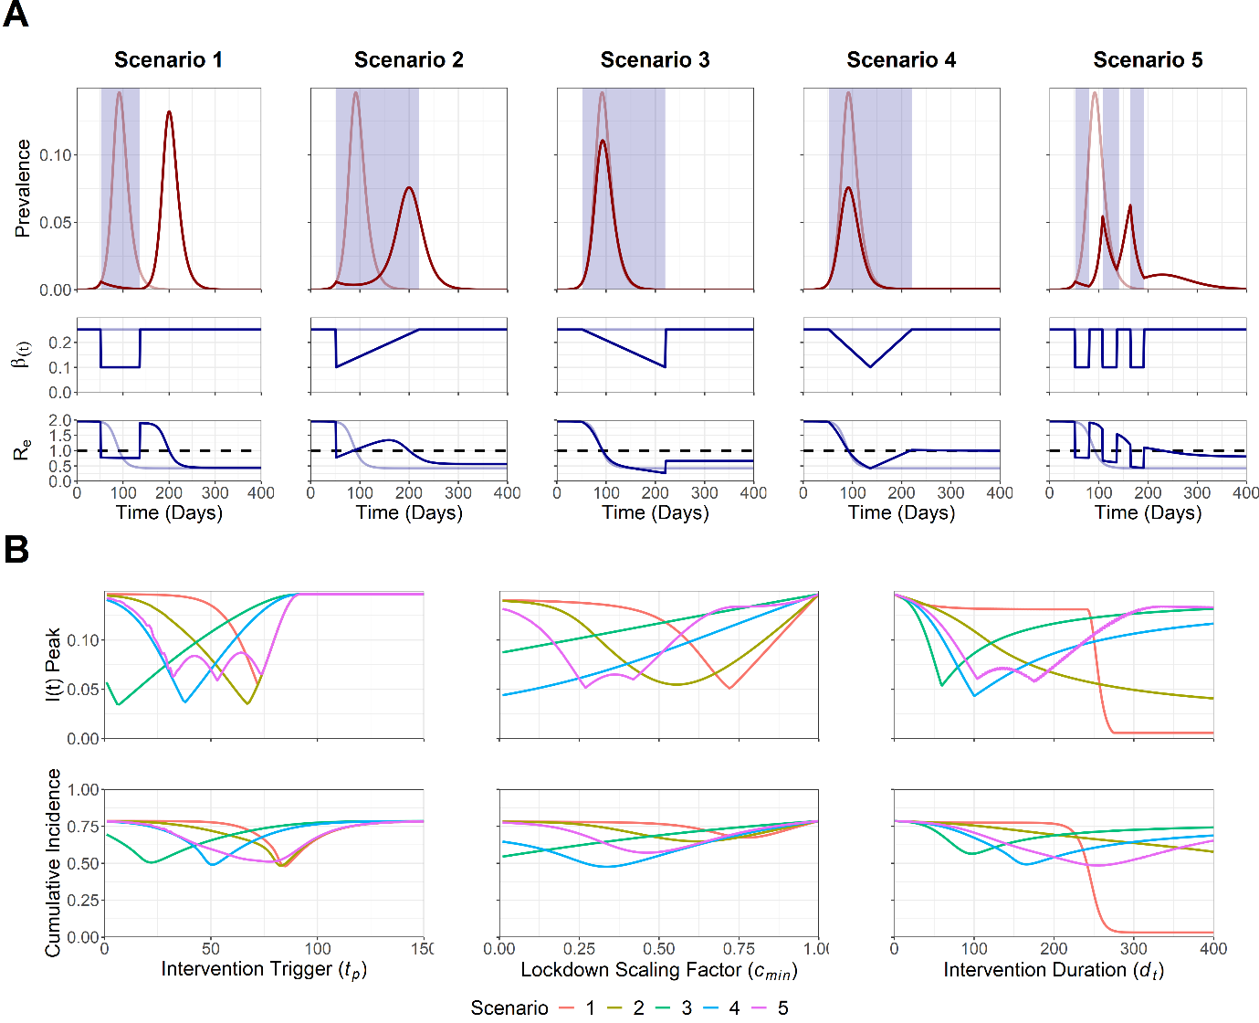

**Figure 1. A) Trajectory plots for the epidemic curve, *β(t)* reductions and *Re* for the five intervention scenarios. B)** **Sensitivity analysis for Intervention trigger day (*tp*), magnitude of lockdown measures (*cmin*) and intervention duration (*dt*) to minimise maximum *I(t)* peak, *Imax*, and total cumulative incidence, *Ic(∞)*.** Note that for A) opaque red and blue lines in the trajectory plot depict unmitigated epidemic curve dynamics.Blue shading indicates the period of the intervention. Dotted line on the *Re* plot denotes the threshold for sustained epidemic growth.Note that for B) scenarios are comparable for a specific explored parameter value, with the duration of scenario 2, 3, 4 and 5 being doubled to ensure similar intervention magnitudes across all scenarios. This was not possible for the intervention duration sensitivity analysis, as the parameter value remains fixed for a specific explored value of *dt*.

Sensitivity analyses were also conducted to observe the sensitivity of the maximum *I(t)* peak, *Imax*, and the total cumulative incidence, *Ic(∞)* to the intervention trigger day (*tp*), magnitude of lockdown measures (*cmin*) and intervention duration (*dt*) parameters (**Figure 1B**). Each sensitivity analysis was conducted with all other parameters held at baseline levels. A range of early-to-intermediate optimal trigger points (7 ≤ *tp* ≤ 74) to minimise *Imax* were identified across all five scenarios. These optimums were highly sensitive to suboptimal deviations from the optimal *tp* value for scenario 1, 2, 3 and 4, with similar steep increases in *Imax* and *Ic(∞)* either side of the *tp* optimum suggesting that intervening too early/late makes little difference in the context of preventing increases in *Imax* and *Ic(∞)* with a poorly timed, suboptimal intervention. In contrast, an early intervention was more beneficial to minimise *Imax* and *Ic(∞)* for scenario 3, and with a large range of optimal trigger points being observed for scenario 5 (32 < *tp* < 74).

Stronger interventions were found to be more optimal to minimise *Imax* and *Ic(∞)* for scenario 3 and 4. In contrast, scenario 1, 2 and 5 were able to optimally minimise both outcome measures using an intermediate strength intervention (0.27 ≤ *cmin* ≤ 0.72). We note that despite the optimums observed for scenario 1, 2 and 5, it was still more beneficial to intervene too strongly than insufficiently, with lower suboptimal *cmin* values being more capable of minimising *Imax* and *Ic(∞)*, compared to suboptimal values of *cmin* which were too high. This was observed through the steeper increase in both outcome measures as greater-than-optimal *cmin* values were chosen, relative to *cmin* values which were lower-than-optimal. Longer intervention durations were found to be optimal to reduce *Imax* and *Ic(∞)* for scenario 1 and 2. Intermediate length interventions were found to be optimal for all other scenarios (60 ≤ *dt* ≤ 175). However, we note that if a suboptimal intervention duration is introduced, it is more beneficial to intervene for too long, with increases in *Imax* and *Ic(∞)* being less severe in an intervention that is longer than optimal, compared to an intervention that is shorter than optimal.

To explore the interplay between multiple model parameters, a sensitivity analysis was next conducted to identify the optimal parameter space to minimise *Imax* and *Ic(∞)* for a multi-dimensional parameter space: 1) Intervention trigger day (*tp*) and 2) Intervention duration (*dt*) (**Figure 2**).

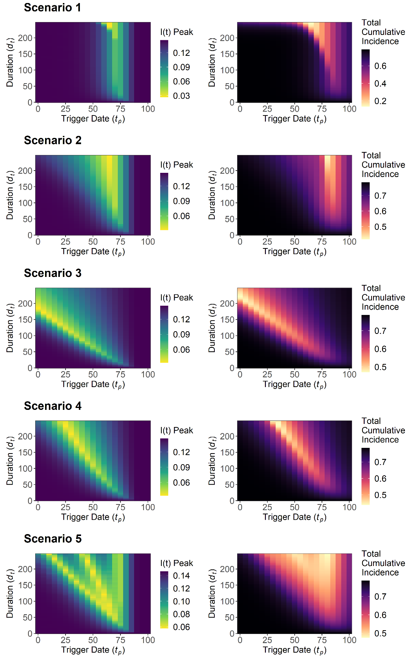

**Figure 2. Sensitivity analysis for maximum *I(t)* peak, *Imax*, and total cumulative incidence, *Ic(∞)*, for intervention trigger day, *tp*, and the intervention duration, *dt*. This was explored for the five intervention scenarios.** Note that for a specific value of *dt*, scenario 1 is not comparable with scenario 2, 3, 4 and 5 due to the need to double *dt* for the latter scenarios to ensure a comparable intervention magnitude over the intervention duration. This is not possible for this sensitivity analysis with *dt* being a fixed explored parameter and heatmap legends will therefore differ across scenarios.

A long intervention duration (*dt* > 200) and an intermediate trigger point (*tp* = 65) was optimal for scenario 1 and 2 to minimise *Imax* and *Ic(∞)*. However, upon achieving the optimal intervention trigger, a large range of intervention durations could be used with negligible impact to either outcome measure (10 ≤ *dt* ≤ 200). A different qualitative pattern was observed in scenario 3 and 4, with decreases to the intervention duration being necessary to maintain the optimal parameter space with a later intervention trigger. Rough qualitative agreement was found between the overall optimal parameter space for both outcome measures across all scenarios.

Increasing the length of the intervention was found to compensate for suboptimal choices of the intervention trigger in scenario 2, 3, 4 and 5, with both *Imax* and *Ic(∞)* being less sensitive to suboptimal deviations from the optimal intervention trigger point as the duration of the intervention was increased. We also note the existence of suboptimal trigger point “gaps” in scenario 5, with increases and decreases in *Imax* as the trigger point was varied. This resulted from the fixed periods between pulsed interventions, with these “gaps” increasing as the duration of the overall intervention increased. This was found to be less pronounced for *Ic(∞)* relative to *Imax*.

The sensitivity analysis was repeated with *cmin* = 0.25/0.5/0.75 to assess the sensitivity of the *dt*/*tp* relationship to alterations to the magnitude of the intervention (**Figure S3 + 4**). Low-intermediate *cmin* values of 0.25 (scenario 1, 2 and 3) and 0.5 (scenario 3 and 4) were found to be more optimal to minimise *Imax*, with the lowest explored value of *cmin* being optimal to minimise *Ic(∞)* for all scenarios.

We note that NPIs and population lockdown measures are often not considered in isolation, and are instead introduced as package of measures, or with the expectance that strong NPIs may be introduced at a later date to tackle epidemic resurgence. To model this, two sequentially implemented lockdown measures were introduced for each of the five scenarios (**Figure 3**).

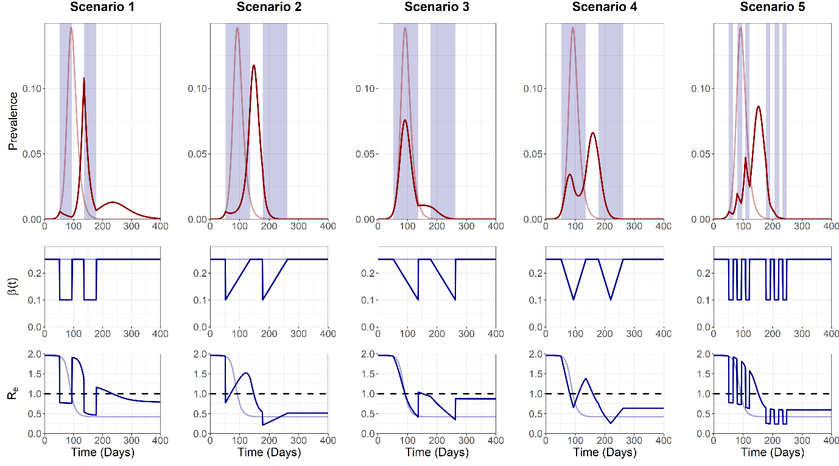

**Figure 3. Trajectory plots for the epidemic curve, intervention associated R0 reductions and Re, for the five “double” intervention scenarios.** Opaque red and blue lines depict unmitigated epidemic curve dynamics.Blue shading on the trajectory plot indicates the period of the intervention. Dotted line on the *Re* plot denotes the threshold for sustained epidemic growth.

Scenario 1 and 2 displayed similar dynamics to the single intervention scenarios, with a delayed epidemic peak and *Re* driven sharply below 1 during the interventions. A third epidemic peak was also observed in scenario 1, with *Re* > 1 occurring transiently after the cessation of the second intervention. Subtly different dynamics were observed for scenario 2, with the gradual relaxation following the initial reduction to *β(t)*, resulting in an earlier epidemic peak relative to scenario 1. This resulted in the post-peak introduction of the second intervention, with minimal effect on the epidemic curve. Scenario 3 and 4 were characterised by gradual reductions to *Re* < 1, with ramping up of the intervention and population immunity preventing sustained increases in *Re* above 1 for a sufficient period of time to cause a large delayed epidemic peak. Controlled reductions to *β(t)* and the effects of population immunity were found to gradually reduce *Re* > 1 in scenario 5. However, we note this gradual pulsed approach resulted in Re > 1 at a later date relative to the other scenarios, allowing for a sizeable delayed epidemic peak.

A sensitivity analysis was next conducted with the multiple intervention model to explore the optimal parameter space to minimise *Imax* and *Ic(∞)* for two sets of parameters: 1) Intervention 1 trigger date, *tp1*, and Intervention 2 trigger date, *tp2,* and 2) Intervention 1, *cmin1*, and Intervention 2, *cmin2* (**Figure 4**).

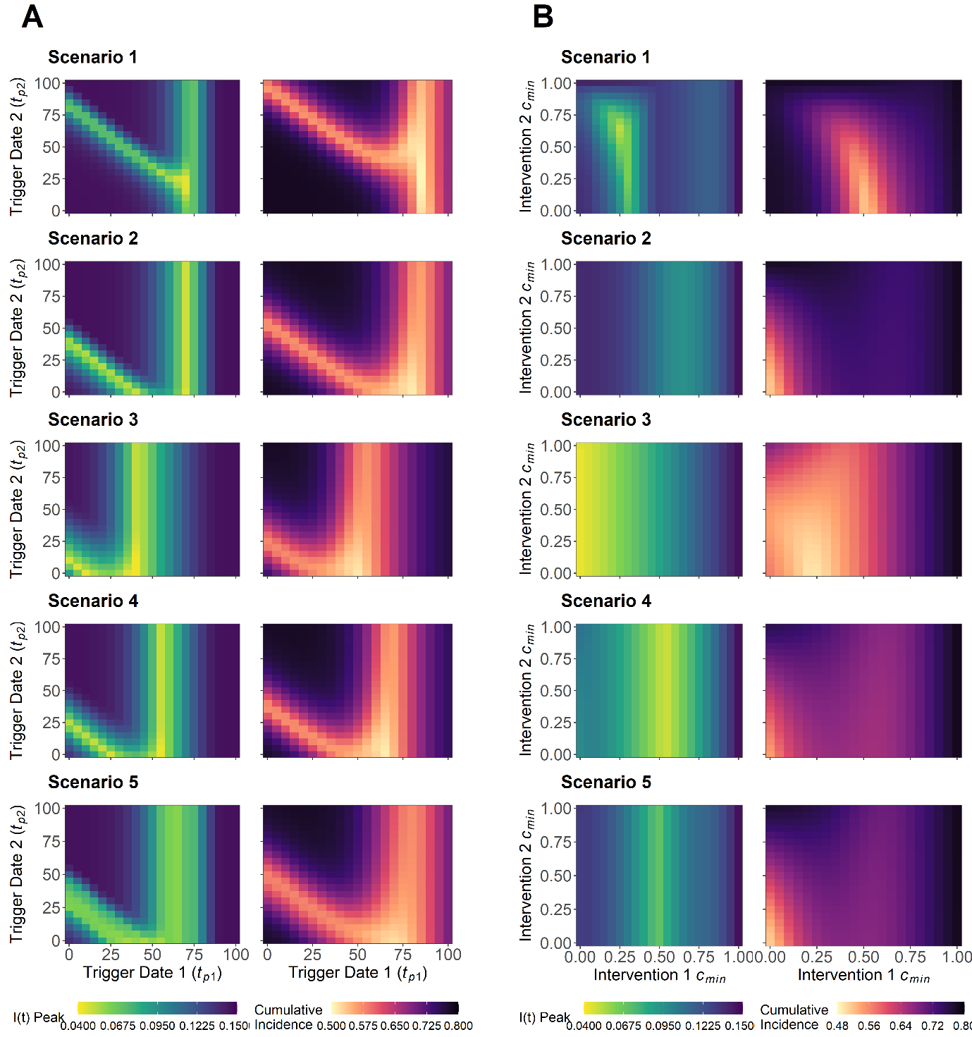

**Figure 4. A) Sensitivity analysis for maximum I(t) peak, *Imax*, and total cumulative incidence, Ic(∞), for intervention 1 trigger date, *tp1*, and intervention 2 trigger date, *tp2*. This was explored for the five intervention scenarios. B) Sensitivity analysis for the** **minimum value of lockdown-related scaling factor *c(t)* for intervention 1, *cmin1*, and intervention 2, *cmin2*.** This was explored for the five intervention scenarios. To ensure comparable overall magnitude of interventions of over the intervention duration, the *dt1*/*dt2* value of Scenarios 2, 3, 4 and 5 were doubled relative to scenario 1 (12 vs 6 weeks). All scenarios are therefore comparable for a given parameter value combination with heat map legends remaining constant for each set of explored parameters.

A large range of trigger points for intervention 2 (1 ≤ *tp2* ≤100) were optimal to minimise *Imax* and *Ic(∞)*, on the condition that the optimal trigger point for intervention 1 was achieved (*tp1* = 65) (**Figure 4A**). This was found to differ if a suboptimal *earlier* intervention 1 trigger point was chosen, with only a narrow selection of optimal intervention 2 trigger points able to compensate for the suboptimal *tp1* value. The choice of a *later* than optimal intervention 1 trigger was found to completely negate the ability for an intervention 2 trigger to prevent increases in *Imax* and *Ic(∞)*, suggesting that it is better to introduce the initial intervention earlier, rather than later, if the optimal intervention 1 trigger point is unknown. Extending the duration of intervention 1 and 2 did little to alter the optimal trigger points for either scenario (**Figure S5-14**).

Optimising the magnitude of intervention 1 was found to be more critical to minimise *Imax* and *Ic(∞)*, with a large range of optimal magnitudes possible for intervention 2 (0 ≤ *cmin2* ≤ 1) if the magnitude of intervention 1 is sufficiently optimised (**Figure 4B**). Scenario 1, 2, 4 and 5 were characterised by an intermediate optimal intervention 1 magnitude (0.25 ≤ *cmin1* ≤ 0.65). Scenario 3 displayed subtly different dynamics, with intervention 1 ideally being as strong as possible (*cmin1* → 0) to optimise reductions to both *Imax* and *Ic(∞)*. Increases in the duration of intervention 1 allowed for greater reductions to *Imax* and *Ic(∞)* for a given *cmin1*/*cmin2* parameter space, relative to baseline parameters (**Figure S15-24**). The exception was scenario 3, with increases in intervention 1 duration resulting in detrimental increases to possible *Imax* and *Ic(∞)* values for a given combination of *cmin1*/*cmin2*.

## **DISCUSSION**

This work builds on previous epidemiological modelling to explore the optimal parameter space to minimise maximum peak prevalence (*Imax*) and total cumulative incidence (*Ic(∞)*) across five different NPI scenarios. We note that there is no single intervention strategy that can be considered the most optimal approach, with each scenario capable of minimizing both *Imax* and *Ic(∞)* for a given set of unique, optimal parameter values.

The optimal parameter space to minimise *Imax*, and to a lesser extent *Ic(∞)*, for each intervention scenario can be attributed to two key characteristics: 1) Intervention peak timing and 2) Intervention *cmin* balance. Matching the timing of an intervention to the epidemic peak is not a novel concept and has been explored previously (**11**). However, we demonstrate that it is also necessary to match the timing of the epidemic peak with the greatest extent of the intervention (*cmin*/*cmin1*/*cmin2*) if reductions to *β(t)* are allowed to vary. This can be intuitively observed by comparing scenario 2 (*cmin* at *tp*) and scenario 3 (*cmin* at *tp* + *dt*) (**Figure 2**), with scenario 2 being optimal at a later trigger day to coincide with the early *cmin* reduction and scenario 3 optimal with an earlier intervention trigger to coincide with the later *cmin* reduction. We also corroborate similar findings in modelling literature by demonstrating that it is optimal for the intervention to maintain *Re* near the threshold for sustained transmission (*Re* ~1), in the context of a time limited intervention (**28, 29**). These intermediate strength interventions allows for the effects of protective immunity to gradually decrease the susceptibility of the population, preventing large rebounds in *Imax* upon the cessation of the intervention.

As suggested by previous research, attainment of these optimums in practice is likely to be difficult (**10**). The ongoing COVID-19 outbreak has highlighted the limited capacity of policy-makers to effectively micromanage the course of an outbreak, with the introduction of policy often only slightly modifying the course of an outbreak (**30, 31**). Factors such as varying public compliance, imperfect disease surveillance, confounding parallel interventions and an implementation lag between the introduced interventions and observable changes in disease prevalence, will contribute to large levels of intervention implementation error **(9, 32, 33)**. If placed in the context of the narrow parameter optimums observed throughout this study, these errors will likely result in serious consequences on COVID-19 associated mortality and morbidity.

Alternatively, a more viable approach could involve the use of sub-optimal interventions. Parallels of these interventions can be observed in the ongoing COVID-19 outbreak, with recurring themes of “hit it hard and fast” providing simple, yet robust advice to policy makers **(34, 35)**. However, as evidenced by the results in this study, these messages are scenario-specific and often nuanced, with different scenarios and parameter choices altering the extent of *Imax* and *Ic(∞)* reductions achieved with suboptimal interventions. We note that for a single time limited intervention, the most effective suboptimal strategy to reduce *Imax* and *Ic(∞)* can be achieved by intervening stronger and for longer than what is considered optimal (**Figure 1 + 2**). Similarly, for the multi-intervention scenario, an earlier and stronger intervention can provide reductions to *Imax* and *Ic(∞)* under suboptimal circumstances (**Figure 4**). However, we note that this only holds true in the context of the initial intervention, with this providing a delaying action allowing for later interventions to compensate and further reduce *Imax* and *Ic(∞)*. This is corroborated in literature, with suggestions that uncertain policy makers could use an earlier intervention to delay the peak if the optimal intervention is unknown, providing time for the build-up of healthcare capacity and the opportunity for later interventions to “course-correct” (**10**).

We also note that NPIs such as population lockdown measures are often considered an integral part of a package of wider measures, often used to drive down the level of infection and “buy” time for the introduction of more sustainable measures, such as contact tracing or vaccination (**36, 37**). This can be attributed to the unsustainable nature of lockdown measures, with detrimental economical, physical and mental health impacts (**3-5**). We note that in this context, it is universally more optimal to introduce the initial lockdown measures earlier, more strongly and for as long as necessary, until more sustainable intervention measures can be introduced indefinitely (**Figure S25**). This corroborates the results obtained from the sub-optimal analysis of the time-limited single/multi intervention scenarios, and provides support for the current rationale of “hard and fast” introduction of intervention measures.

In contrast to the SIR model structure used by this study, we note that an SEIR framework could be considered more accurate to describe the epidemiological characteristics of SARS-COV-2 **(38)**, with a delay observed between the intervention and observed effects in *I(t)* (**Figure S26)**. However, this was considered unnecessary, with the aim of this study to describe the existence and patterns of intervention optimums, and not describe the exact timing of said optimums. We also note that the addition of this compartment would likely increase the number of assumptions underlying the model, with both the infectious and an incubation period possessing implicitly assumed exponentially distributed waiting times (**39**). However, we note that this could be resolved through the use of Erlang or gamma distributed waiting times in future analyses (**40**).

An assumption of life-long immunity was also assumed following SARS-COV-2 infection. This choice was made due to the large amount of uncertainty regarding the immunological characteristics of the virus, which is currently under debate (**41, 42**). Particular avenues for future research, could include modelling impact of waning immunity or cross-reactivity and how this could impact the optimal and sub-optimal parameter spaces highlighted in this study (**40**).A relatively simple disease metric was also used for this study, with an optimal intervention able to reduce maximum peak prevalence, *Imax*, and total cumulative incidence, *Ic(∞)*. While outside of the scope of this study, the use of other epidemiologically relevant outcome measures such as occupied ICU capacity or deaths per 100,000 population may be of interest when investigating optimal COVID-19 interventions in a more policy-relevant context **(28)**. This could also be complemented by an exploration into the impact of individual or population level variation of risk on intervention optimisation. For example, investigating intervention optimisation in the context of a realistic age-structured population or with regards to the impact of individual-level overdispersion in transmission (**43-45**).

Although we describe the possibility of optimising various intervention strategies throughout this study, it was not the intention to propose this as a singular solution for COVID-19 epidemic control. The results described in this study are highly nuanced, with narrow intervention optimums and a number of other factors likely preventing the trajectory of an epidemic conforming uniformly to the dynamics observed in this study. Instead, greater interest should be placed on the concept of sub-optimal approaches and using the quantitative modelling frameworks, such as the one implemented in this study, to quantify pre-existing outbreak control logic, such as “hit it hard and fast”. This has the additional benefit of being a risk-averse approach, which is often favourable during the initial stages of the outbreak, where the potential impact of risky public health policy can lead to disastrous consequences. Finally, we note that the evidence from this study should be taken into context with the work tirelessly undertaken by the wider epidemiological and modelling community. It is only through this collaboration and synthesis that effective and altruistic public health policy can be generated to combat the COVID-19 pandemic.

## **REFERENCES**

## 

1. Prevention CfDCa. Nonpharmaceutical Interventions (NPIs) United States: U.S. Department of Health & Human Services; 2020 [updated 27/04/2020. Available from: <https://www.cdc.gov/nonpharmaceutical-interventions/index.html>.

2. Guidance: Staying at home and away from others (social distancing) [press release]. United Kingdom: Cabinet Office, 01/05/2020 2020.

3. Nicola M, Alsafi Z, Sohrabi C, Kerwan A, Al-Jabir A, Iosifidis C, et al. The socio-economic implications of the coronavirus pandemic (COVID-19): A review. Int J Surg. 2020;78:185-93.

4. Pierce M, Hope H, Ford T, Hatch S, Hotopf M, John A, et al. Mental health before and during the COVID-19 pandemic: a longitudinal probability sample survey of the UK population. Lancet Psychiatry. 2020.

5. Pfefferbaum B, North CS. Mental Health and the Covid-19 Pandemic. N Engl J Med. 2020;383(6):510-2.

6. Dickens BL, Koo JR, Lim JT, Park M, Quaye S, Sun H, et al. Modelling lockdown and exit strategies for COVID-19 in Singapore. The Lancet Regional Health-Western Pacific. 2020:100004.

7. Stewart H, Sample I. Coronavirus: enforcing UK lockdown one week earlier 'could have saved 20,000 lives'2020 20/06/2020. Available from: <https://www.theguardian.com/world/2020/jun/10/uk-coronavirus-lockdown-20000-lives-boris-johnson-neil-ferguson>.

8. Daly M. Coronavirus: Earlier Scottish lockdown 'could have prevented 2,000 deaths'2020 14/06/2020. Available from: <https://www.bbc.co.uk/news/uk-scotland-52617895>.

9. Islam N, Sharp SJ, Chowell G, Shabnam S, Kawachi I, Lacey B, et al. Physical distancing interventions and incidence of coronavirus disease 2019: natural experiment in 149 countries. BMJ. 2020;370:m2743.

10. Morris DH, Rossine FW, Plotkin JB, Levin SA. Optimal, near-optimal, and robust epidemic control. arXiv preprint arXiv:200402209. 2020.

11. Di Lauro F, Kiss IZ, Miller J. The timing of one-shot interventions for epidemic control. medRxiv. 2020:2020.03.02.20030007.

12. Gevertz J, Greene J, Tapia CHS, Sontag ED. A novel COVID-19 epidemiological model with explicit susceptible and asymptomatic isolation compartments reveals unexpected consequences of timing social distancing. medRxiv. 2020.

13. Miclo L, Spiro D, Weibull J. Optimal epidemic suppression under an ICU constraint. arXiv preprint arXiv:200501327. 2020.

14. Rawson T, Brewer T, Veltcheva D, Huntingford C, Bonsall MB. How and when to end the COVID-19 lockdown: an optimization approach. Frontiers in Public Health. 2020;8:262.

15. Bin M, Cheung P, Crisostomi E, Ferraro P, Lhachemi H, Murray-Smith R, et al. On fast multi-shot covid-19 interventions for post lock-down mitigation. arXiv preprint arXiv:200309930. 2020.

16. Sadeghi M, Greene J, Sontag E. Universal features of epidemic models under social distancing guidelines. bioRxiv. 2020.

17. Grasselli G, Pesenti A, Cecconi M. Critical Care Utilization for the COVID-19 Outbreak in Lombardy, Italy: Early Experience and Forecast During an Emergency Response. JAMA. 2020.

18. Li R, Rivers C, Tan Q, Murray MB, Toner E, Lipsitch M. Estimated Demand for US Hospital Inpatient and Intensive Care Unit Beds for Patients With COVID-19 Based on Comparisons With Wuhan and Guangzhou, China. JAMA Netw Open. 2020;3(5):e208297.

19. Kermack WO, McKendrick AG. A contribution to the mathematical theory of epidemics. Proceedings of the royal society of london Series A, Containing papers of a mathematical and physical character. 1927;115(772):700-21.

20. Pan A, Liu L, Wang C, Guo H, Hao X, Wang Q, et al. Association of Public Health Interventions With the Epidemiology of the COVID-19 Outbreak in Wuhan, China. JAMA. 2020.

21. Pellis L, Scarabel F, Stage HB, Overton CE, Chappell LH, Lythgoe KA, et al. Challenges in control of Covid-19: short doubling time and long delay to effect of interventions. arXiv preprint arXiv:200400117. 2020.

22. Petersen E, Koopmans M, Go U, Hamer DH, Petrosillo N, Castelli F, et al. Comparing SARS-CoV-2 with SARS-CoV and influenza pandemics. Lancet Infect Dis. 2020.

23. Zhou L, Liu JM, Dong XP, McGoogan JM, Wu ZY. COVID-19 seeding time and doubling time model: an early epidemic risk assessment tool. Infect Dis Poverty. 2020;9(1):76.

24. Flaxman S, Mishra S, Gandy A, Unwin HJT, Mellan TA, Coupland H, et al. Estimating the effects of non-pharmaceutical interventions on COVID-19 in Europe. Nature. 2020.

25. Anderson RM, May RM. Infectious diseases of humans : dynamics and control. Oxford ; New York: Oxford University Press; 1991. viii, 757 p. p.

26. Davies NG, Kucharski AJ, Eggo RM, Gimma A, Edmunds WJ, Centre for the Mathematical Modelling of Infectious Diseases C-wg. Effects of non-pharmaceutical interventions on COVID-19 cases, deaths, and demand for hospital services in the UK: a modelling study. Lancet Public Health. 2020;5(7):e375-e85.

27. Flaxman S, Mishra S, Gandy A, Unwin H, Coupland H, Mellan T, et al. Report 13: Estimating the number of infections and the impact of non-pharmaceutical interventions on COVID-19 in 11 European countries. 2020.

28. Ferguson N, Laydon D, Nedjati Gilani G, Imai N, Ainslie K, Baguelin M, et al. Report 9: Impact of non-pharmaceutical interventions (NPIs) to reduce COVID19 mortality and healthcare demand. 2020.

29. Anderson RM, Heesterbeek H, Klinkenberg D, Hollingsworth TD. How will country-based mitigation measures influence the course of the COVID-19 epidemic? The Lancet. 2020;395(10228):931-4.

30. Hunter DJ. Covid-19 and the Stiff Upper Lip - The Pandemic Response in the United Kingdom. N Engl J Med. 2020;382(16):e31.

31. editorial O. The Observer view on the government's handling of the Covid-19 crisis2020 19/07/2020. Available from: <https://www.theguardian.com/commentisfree/2020/jun/07/the-observer-view-on-the-governments-handling-of-the-covid-19-crisis>.

32. Media P. Fewer young adults sticking to lockdown rules, UK study shows2020 01/08/2020. Available from: <https://www.theguardian.com/world/2020/may/21/fewer-young-adults-sticking-uk-lockdown-rules-study-coronavirus>.

33. Elliot AJ, Harcourt SE, Hughes HE, Loveridge P, Morbey RA, Smith S, et al. The COVID-19 pandemic: a new challenge for syndromic surveillance. Epidemiol Infect. 2020;148:e122.

34. Lagan B. ‘Hard and fast’ plan takes New Zealand through coronavirus crisis2020 20/07/2020. Available from: <https://www.thetimes.co.uk/article/hard-and-fast-plan-takes-kiwis-through-coronavirus-crisis-lnrxvtmxj>.

35. Baker MG, Wilson N, Anglemyer A. Successful Elimination of Covid-19 Transmission in New Zealand. N Engl J Med. 2020.

36. Ferretti L, Wymant C, Kendall M, Zhao L, Nurtay A, Abeler-Dorner L, et al. Quantifying SARS-CoV-2 transmission suggests epidemic control with digital contact tracing. Science. 2020;368(6491).

37. Lurie N, Saville M, Hatchett R, Halton J. Developing Covid-19 vaccines at pandemic speed. New England Journal of Medicine. 2020;382(21):1969-73.

38. Backer JA, Klinkenberg D, Wallinga J. Incubation period of 2019 novel coronavirus (2019-nCoV) infections among travellers from Wuhan, China, 20-28 January 2020. Euro Surveill. 2020;25(5).

39. Krylova O, Earn DJ. Effects of the infectious period distribution on predicted transitions in childhood disease dynamics. J R Soc Interface. 2013;10(84):20130098.

40. Kissler SM, Tedijanto C, Goldstein E, Grad YH, Lipsitch M. Projecting the transmission dynamics of SARS-CoV-2 through the postpandemic period. Science. 2020;368(6493):860-8.

41. Randolph HE, Barreiro LB. Herd Immunity: Understanding COVID-19. Immunity. 2020;52(5):737-41.

42. Mahase E. Covid-19: Where are we on immunity and vaccines? : British Medical Journal Publishing Group; 2020.

43. Gomes MGM, Aguas R, Corder RM, King JG, Langwig KE, Souto-Maior C, et al. Individual variation in susceptibility or exposure to SARS-CoV-2 lowers the herd immunity threshold. medRxiv. 2020.

44. Britton T, Ball F, Trapman P. A mathematical model reveals the influence of population heterogeneity on herd immunity to SARS-CoV-2. Science. 2020.

45. Davies NG, Klepac P, Liu Y, Prem K, Jit M, group CC-w, et al. Age-dependent effects in the transmission and control of COVID-19 epidemics. Nat Med. 2020;26(8):1205-11.